Students in a group of 3 can choose which case the groups want to work on. And need to present the work at week 13 or depend on the lecturer’s.

Case A :

Bee-Express is a new startup company that offer a solution for logistic distribution. To reduce the operational cost, they have to optimize the fuel usage for each car that used to distribute the logistic. Therefore, they have a plan to design the system that help the company to create an optimal travelling plan for each driver from one point to another point as described below

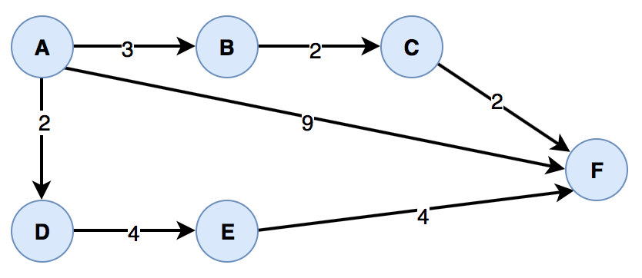

Each driver, **only have 1 trip plan for each day**. Therefore for example, Driver X want to go to from A to F, the optimal solution is through A - B - C - F with a total cost is 7. The company has more than 1 driver and if this process can be computed automatically each day, will help the company to optimize the fuel cost.

Currently the company only served the Jabodetabek area. The office is at Palmerah. You need to have at least the route option in Jabodetabek, used the district in Jabodetabek as your sources information.

As a developer, the company is need your help to design the system and solve the problem!

At week 13, the work that you need to present and submit to your Lecturer are :

1. Presenting about the data that you used
2. Demo you application

You can explore and be as creative as possible and please inform your work to your Lecturer.

Case B :

Bee-Library is a new startup company that offer a solution for a library. One of their product is to manage all the book inside the library. To make a differentiation with another competitor they have to give a reliable search feature to help the librarian to find a book.

For an early stage, search only available by a book’s unique id (barcode) and the system is need to give a fast response for the result. The book recorded can be more than 10 million, therefore the sequential search is not an option as solution because it will take a long time to give a response.

As a prototype you need to be able to demo the search for at least 100 books. You also can use the time or other information to show that using BST is faster than sequential search.

As a developer, the company is need your help to design the system and solve the problem!

At week 13, the work that you need to present and submit to your Lecturer are :

1. Presenting about your search engine and the comparation result
2. Demo you application

You can explore and be as creative as possible and please inform your work to your Lecturer.